**Exercise 9: Idoc to File via SAP CPI**

**Table of Contents**

**1.** **Designing Integration Flow IDOC to SFTP (Outbound)** 4

**Configuration Steps in ECC** 6

**Testing** 9

# **Designing Integration Flow IDOC to SFTP (Outbound)**

Step 1: Create a package (Use existing package of exercise 1)

Step 2: Create an Iflow as “IDoctoSFTP_<userID>”

Step 3: Connect the Sender Participant to start message with IDoc adapter. Connect the end message and receiver participant with SFTP adapter.

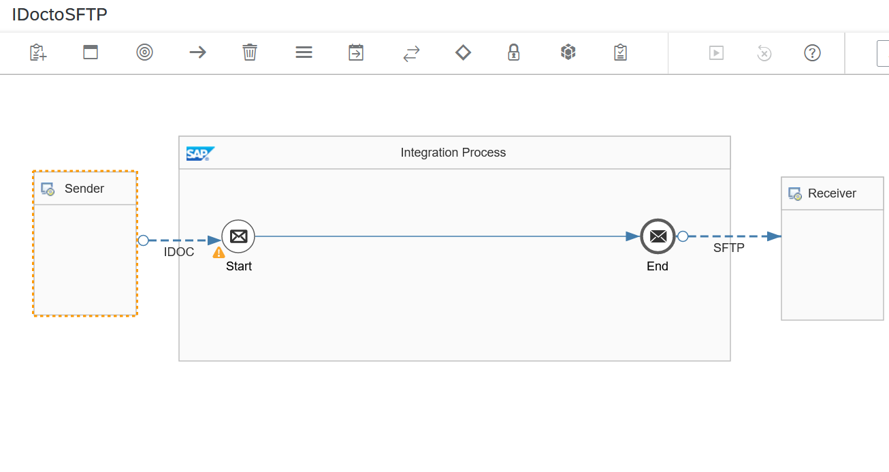

Step 4: Configure the IDoc sender as per below Screenshot. Replace the XXXXX in the below screen with your userid.

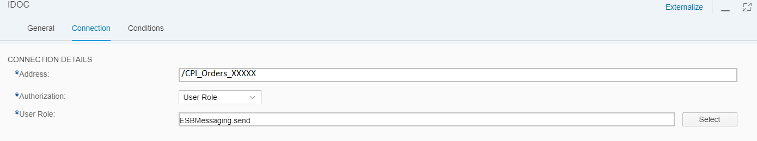

Step 5: Configure the SFTP receiver as per below Screenshot.

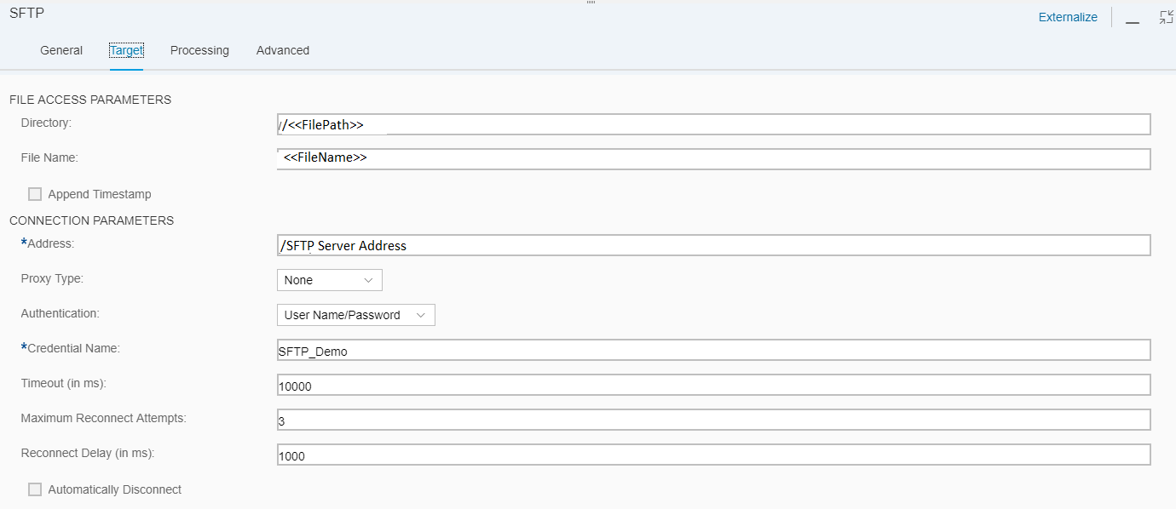

SFTP on Premise Credentials should be deployed in the Manage Security Material Tab.

Overview---->Manage Security Material

Click on Add ---> User Credentials

Enter the SFTP User ID and password and give the Name as SFTP_Demo_<<User ID>>

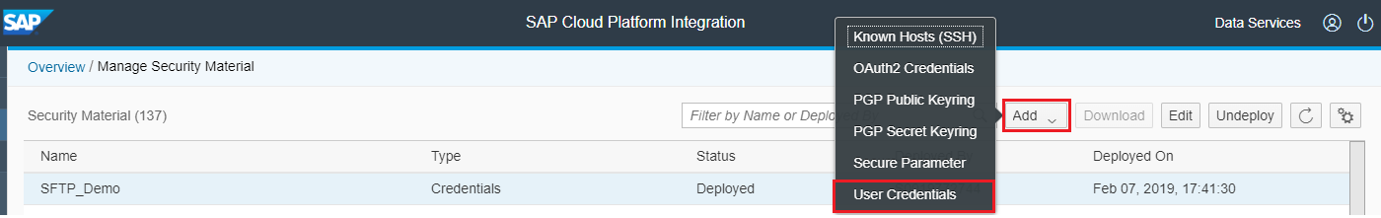

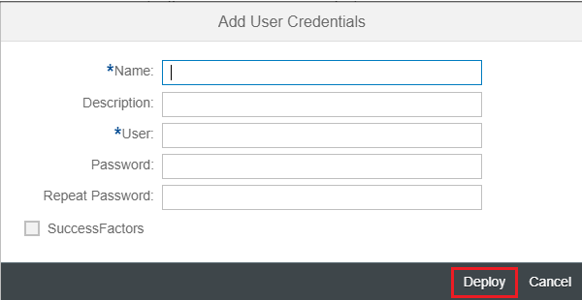

**Now this Credential Name will be called in Channel.**

## **Configuration Steps in ECC**

Step 1: Creation of Logical System

Go to transaction BD54 and create the logical system for CPI

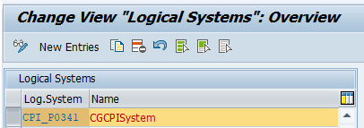

Step 2: Creation of Port in WE21

Go to transaction WE21 and create XML HTTP Port

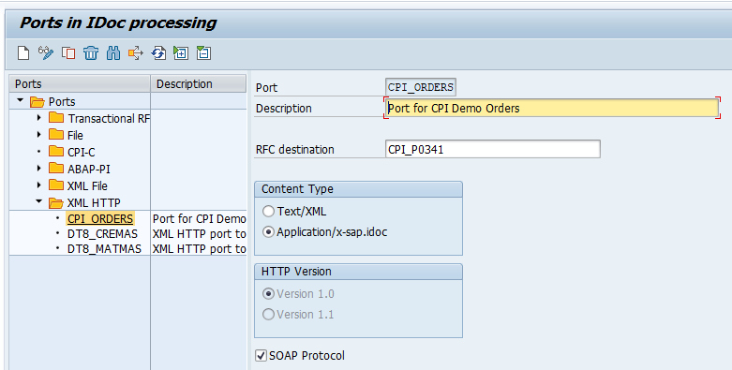

Step 3: Creation of RFC Destination of Type “G”. Note that path prefix should be as per your path you have defined while creating the IDOC channel(connection details->address).

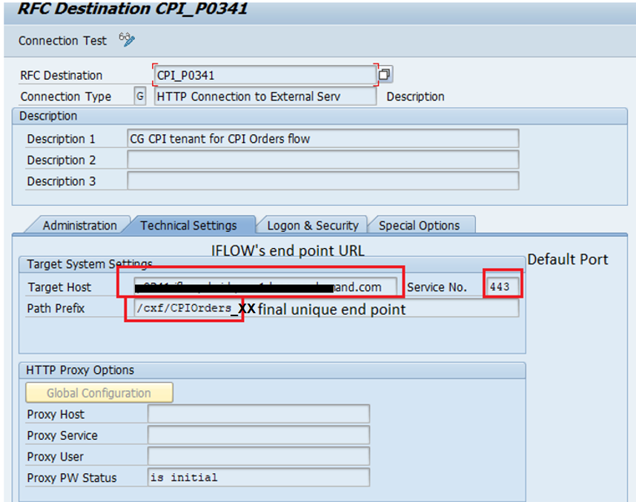

Go to Logon & Security Tab

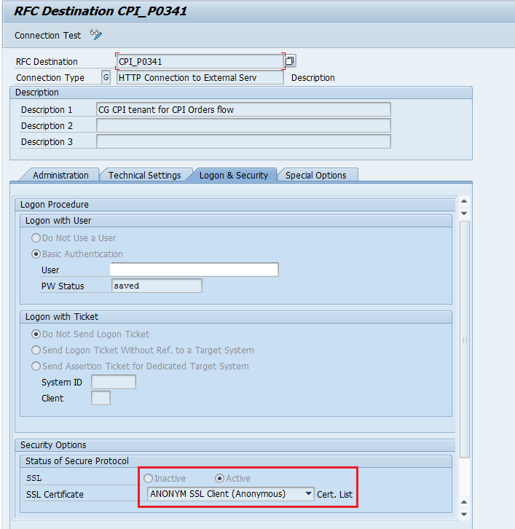

Step 4: Make sure that Certificate is available.

Go to Transaction code, STRUST

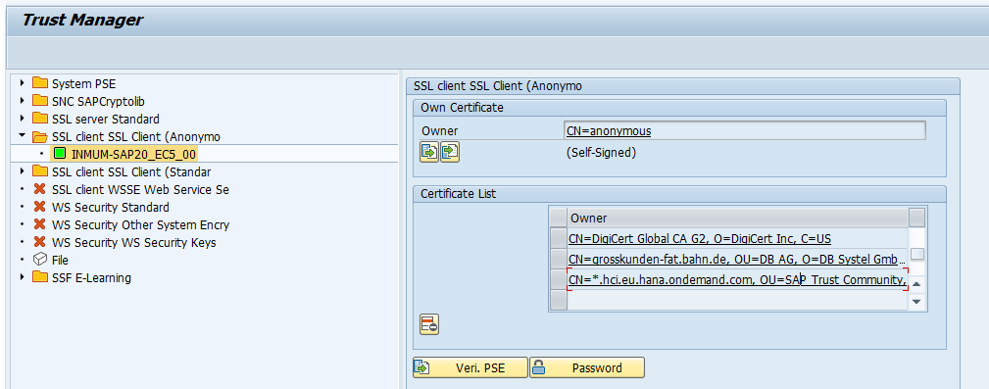

Step 5: Create Partner Profile

Go to Transaction WE20

Create a new Partner Profile of type LS and add ORDERS (Example) as outbound parameters

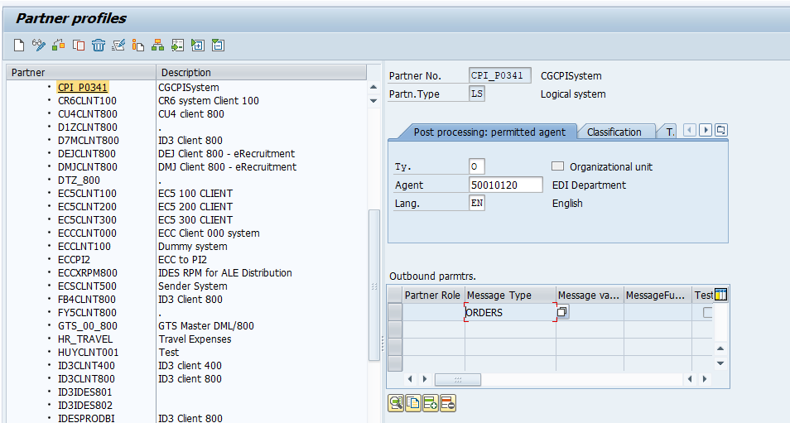

Step 6: Double click on the message type ORDERS

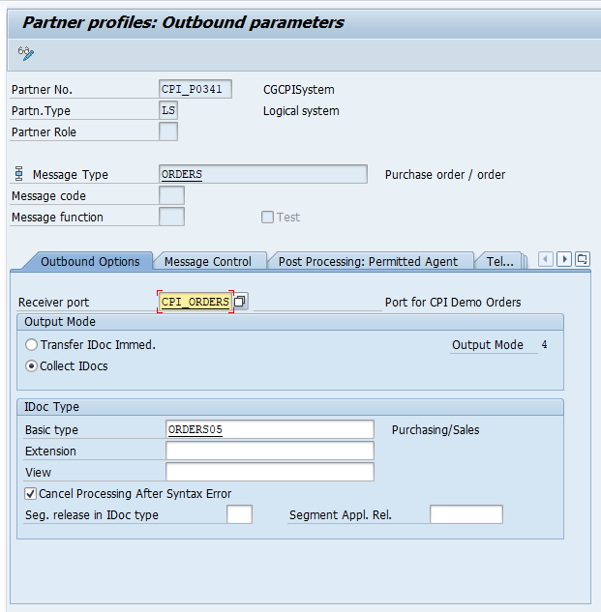

Add the Basic Type and Receiver port which we created in WE21 of type XML HTTP and save it.

Now we are done with ECC Configuration Part.

## **Testing**

For testing purpose, we are using the existing IDoc and triggering from WE19

Step 7: Open WE19 and Enter the IDoc details and press F8

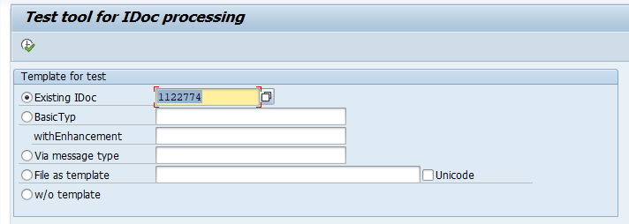

Step 8: Click on Standard Outbound processing

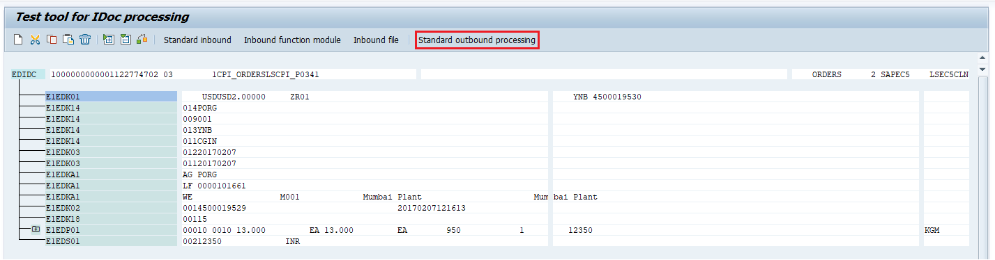

Step 9: Make sure the Receiver Port, Port Type and Internet address are pointing to CPI system and click OK

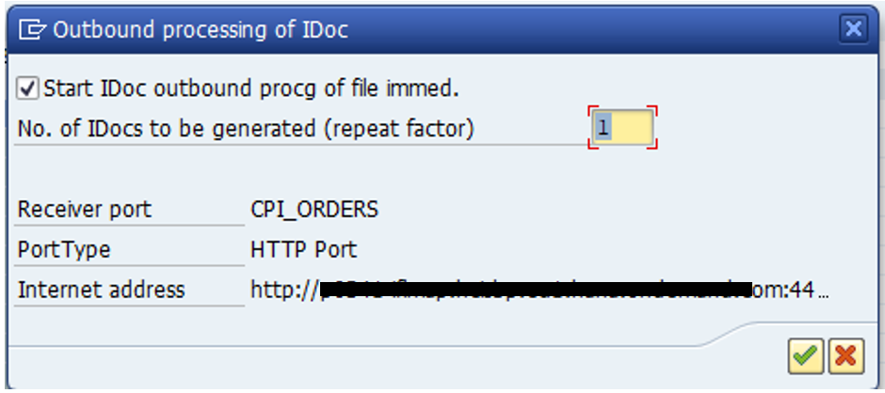

Step 10: Information will be displayed like below

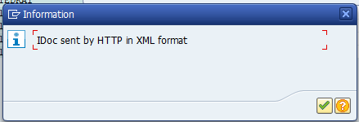

IDOC Number: 1122784

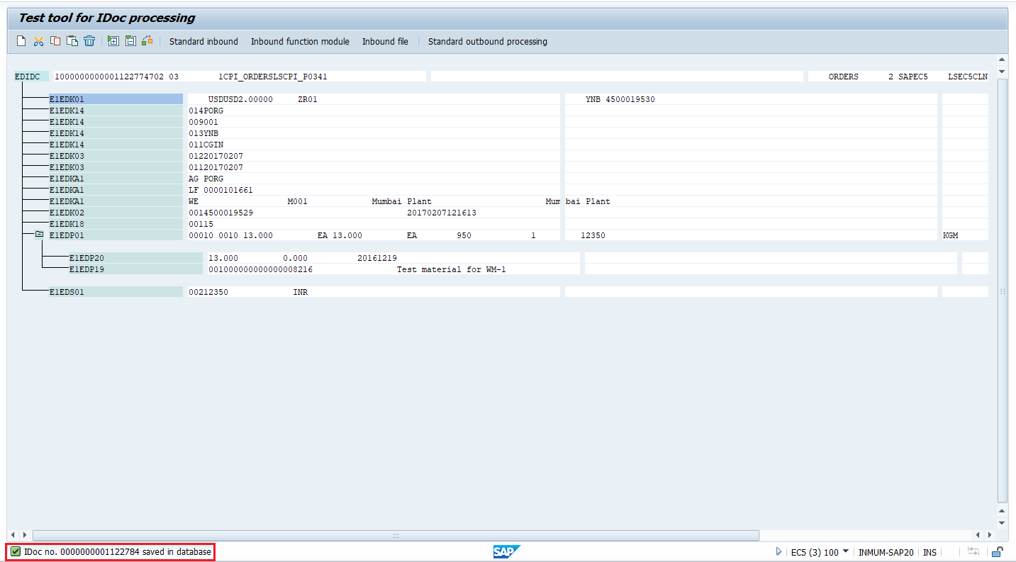

Step 11: now we can check for the IDoc in CPI. Open CPI---> Operations View--->Message Monitor Processing---> All Messages

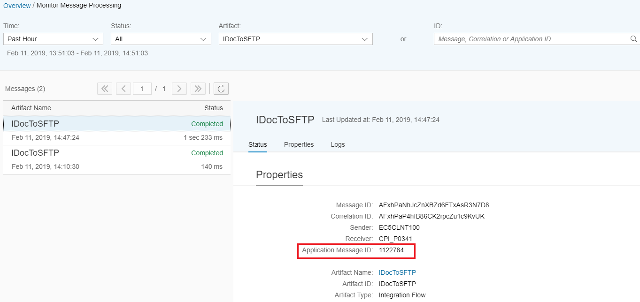

Step 12: Open WinSCP and check for file in /incoming/Receiver

